1:write program to test Hello World.

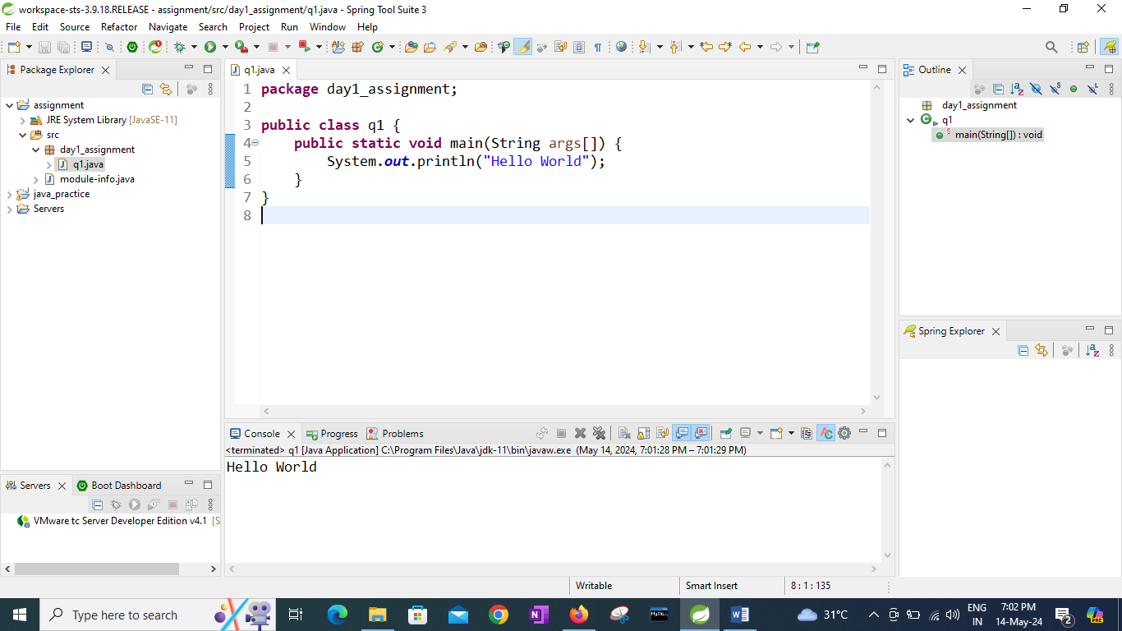

2:Write a program to adddition of two numbers .

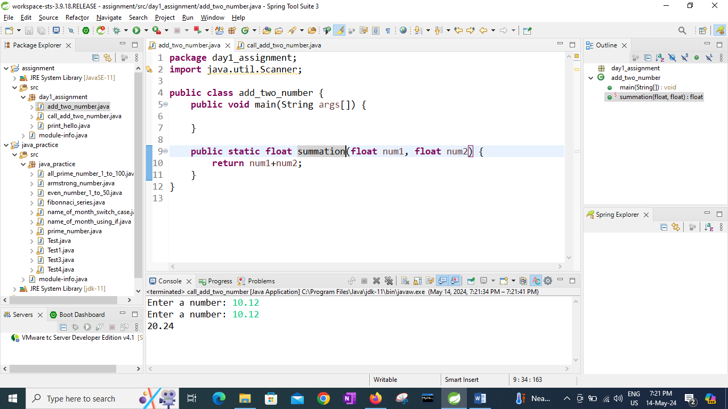

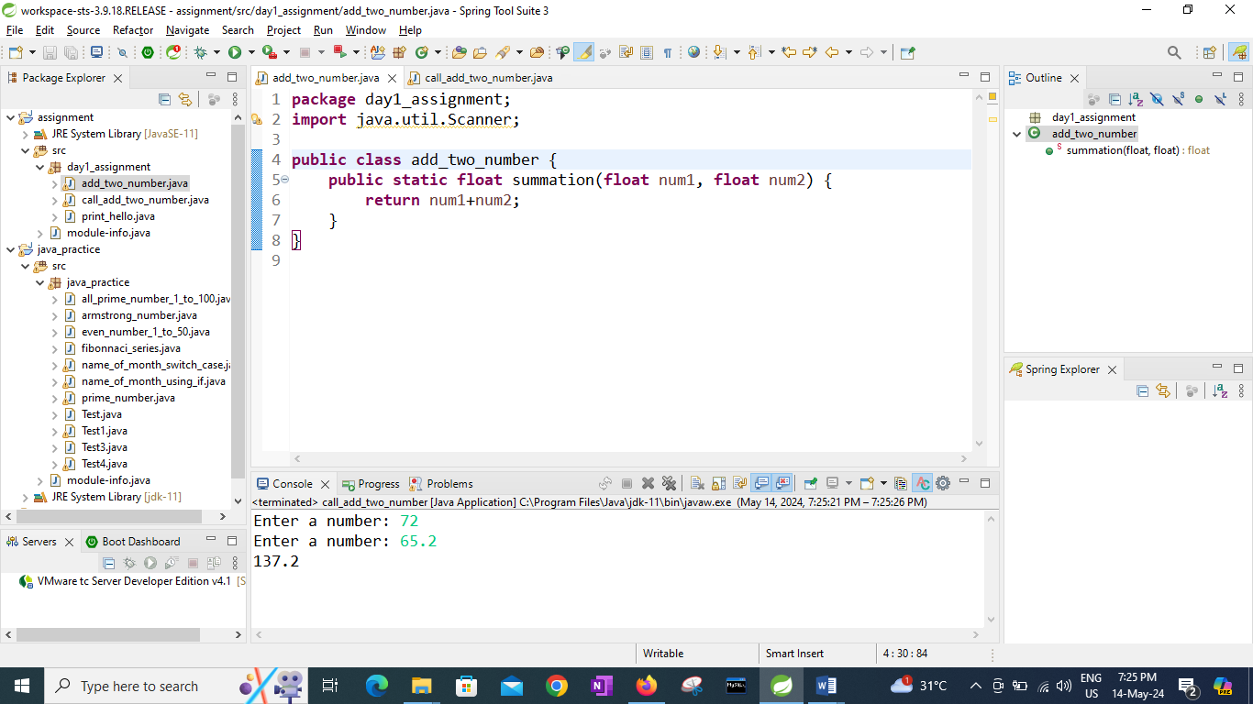

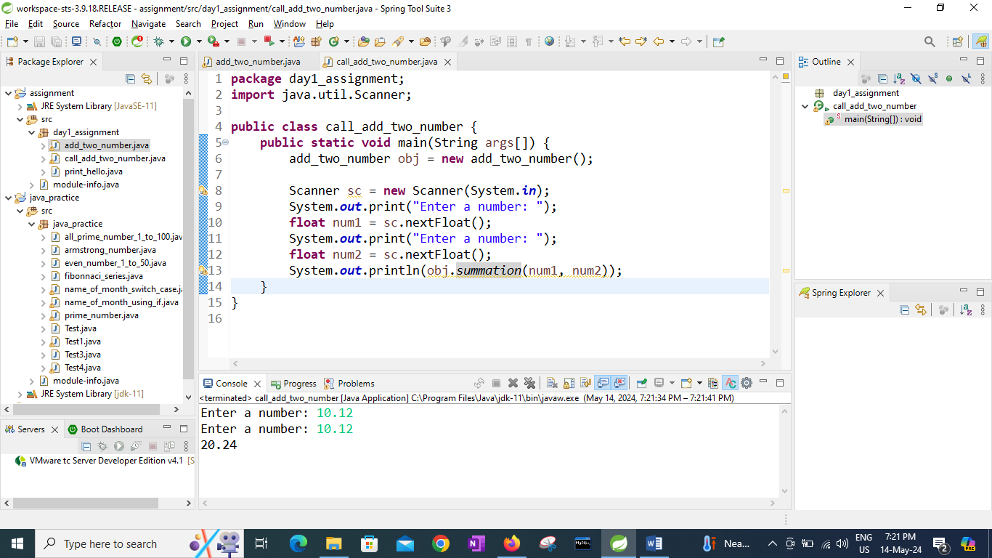

3:Write a program to swap two numbers.

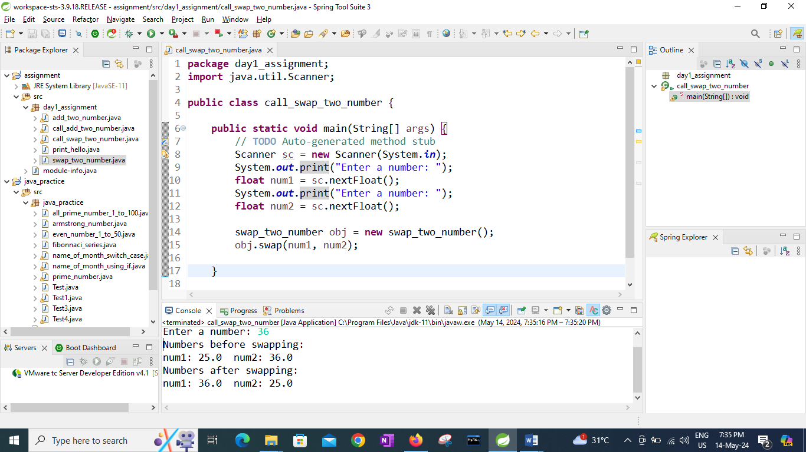

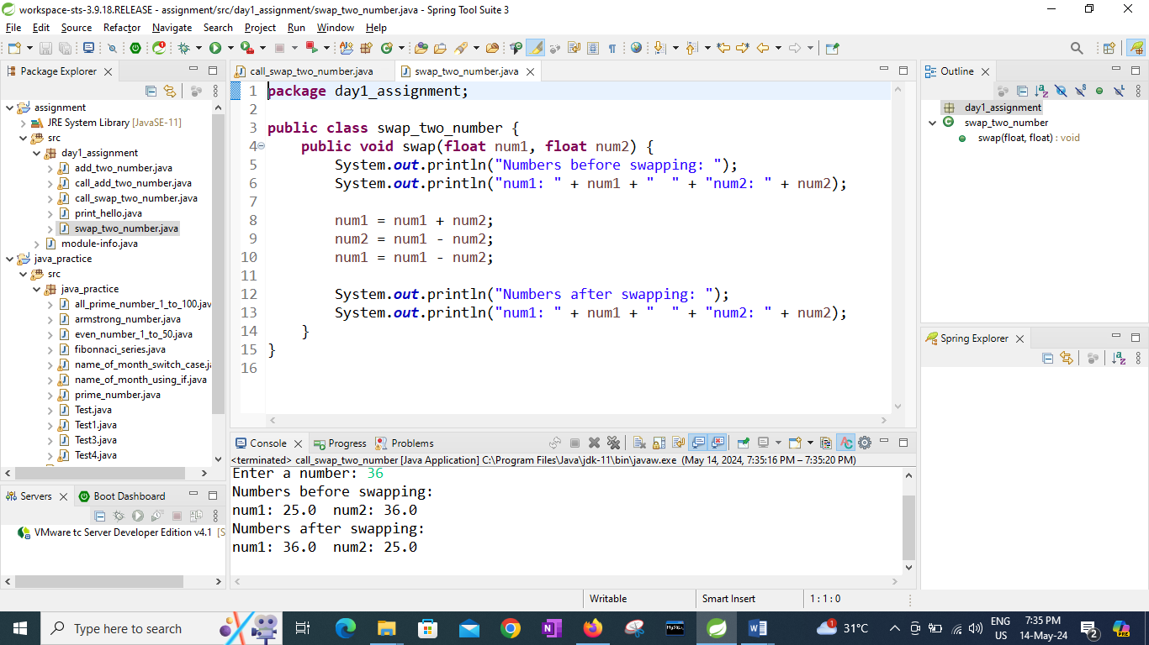

4. Write a program to accept an integer and check if it is even or odd.

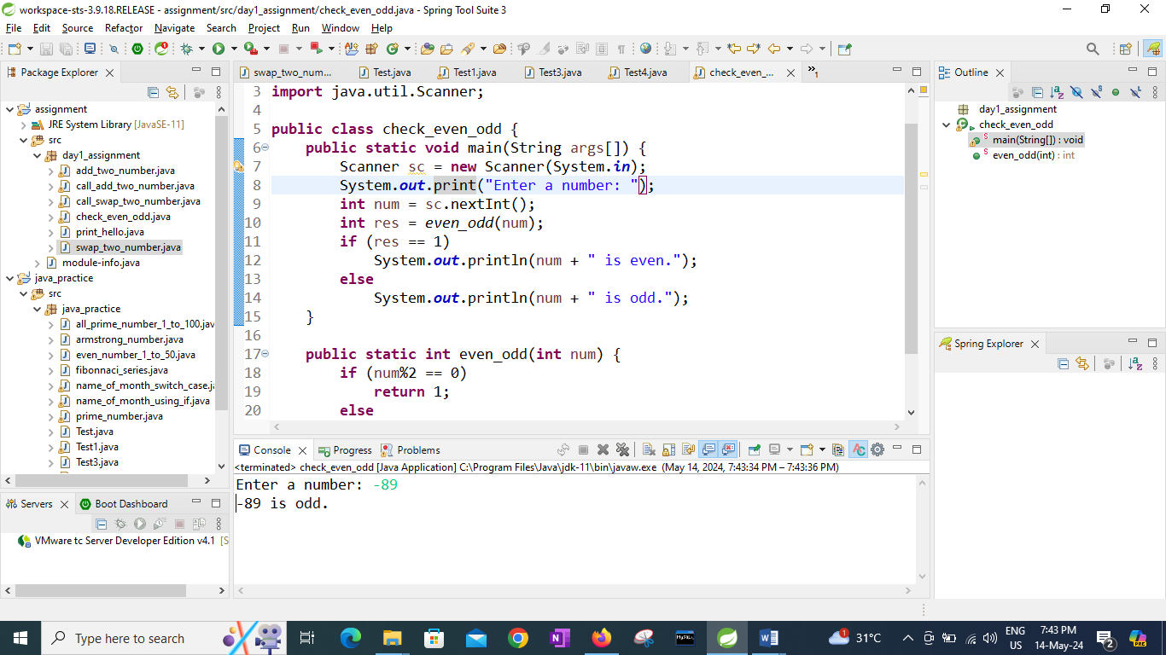

5. Write a program to accept a number and check if it is divisible by 5 and 7.

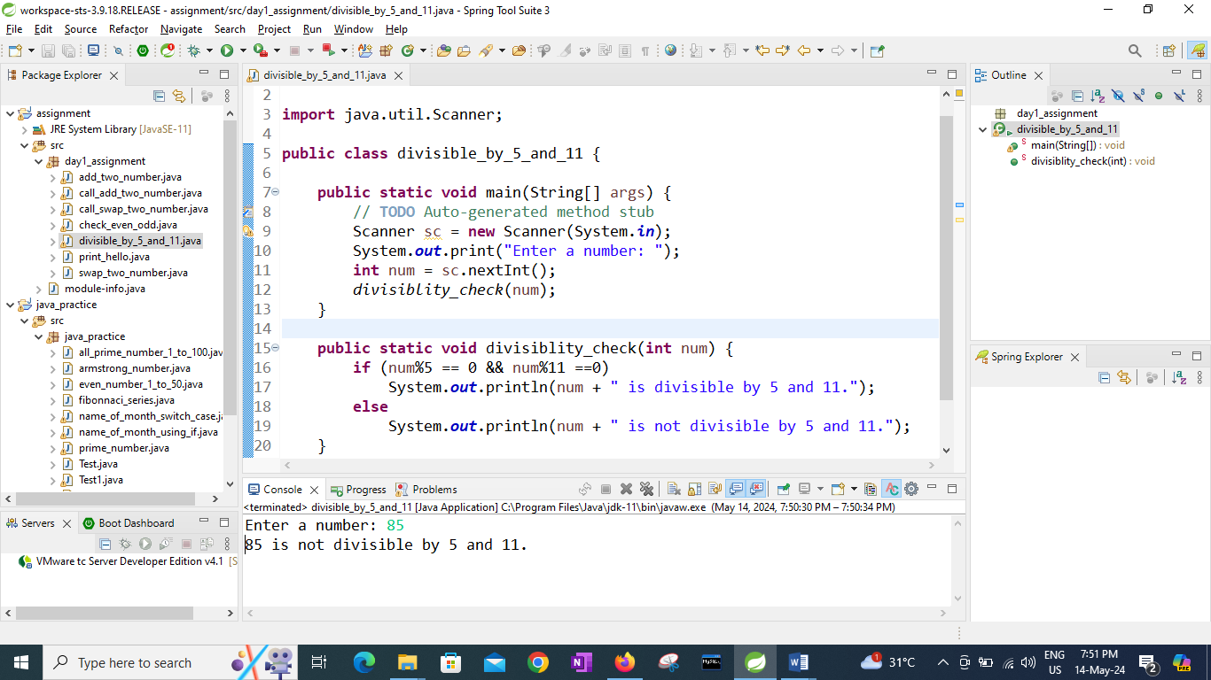

6. Write a program, which accepts annual basic salary of an employee and calculates and displays the

Income tax as per the following rules.

Basic: < 1, 50,000 Tax = 0

1, 50,000 to 3,00,000 Tax = 20%

> 3,00,000 Tax = 30%

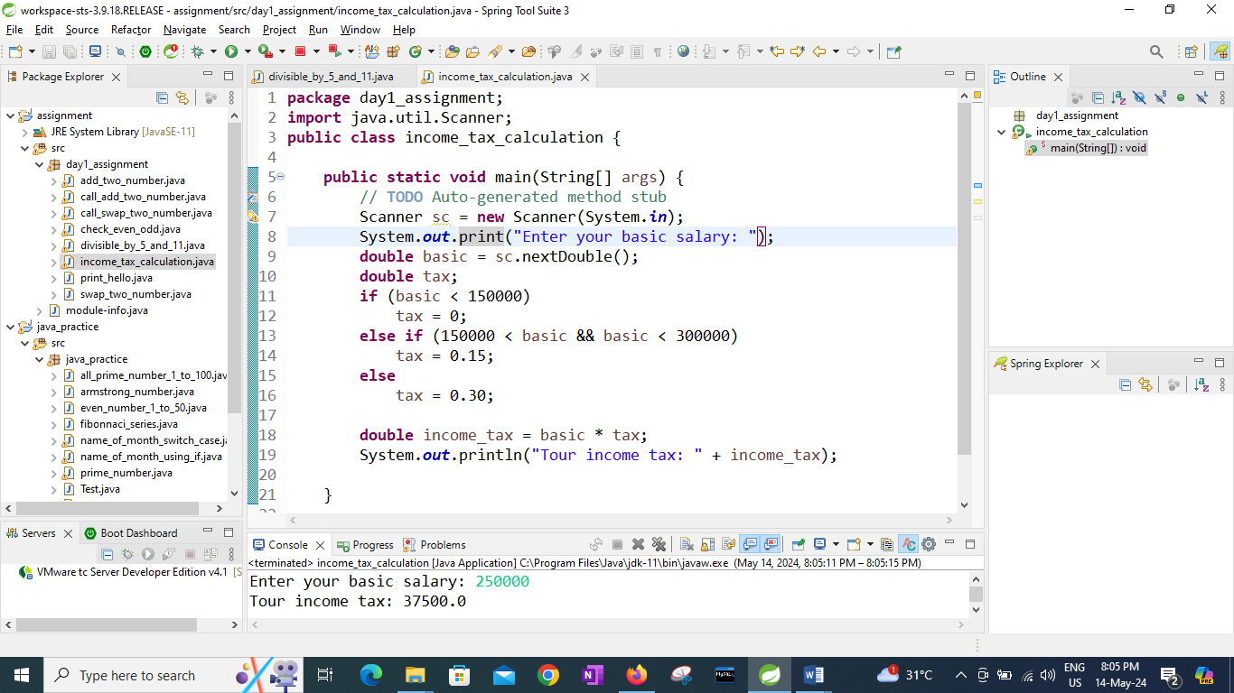

7. Accept a lowercase character from the user and check whether the character is a vowel or consonant.

(Hint: a, e, i, o, u are vowels)

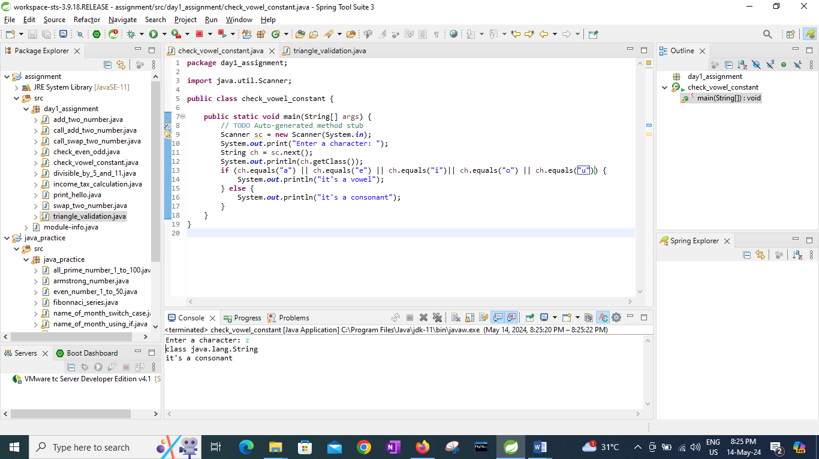

8. Write a C program to input angles of a triangle and check whether triangle is valid or not.

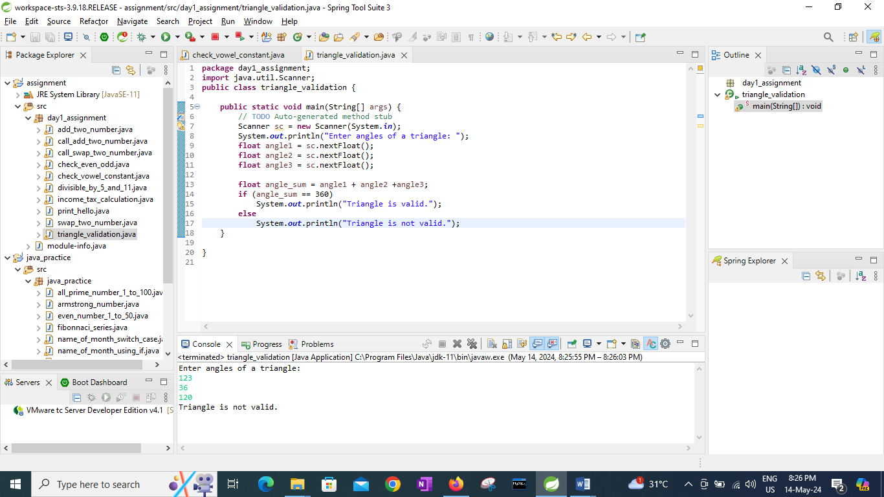

9:Write a program to find factorial of a given number. ex:no5 fact=5\*4\*3\*2\*1=120

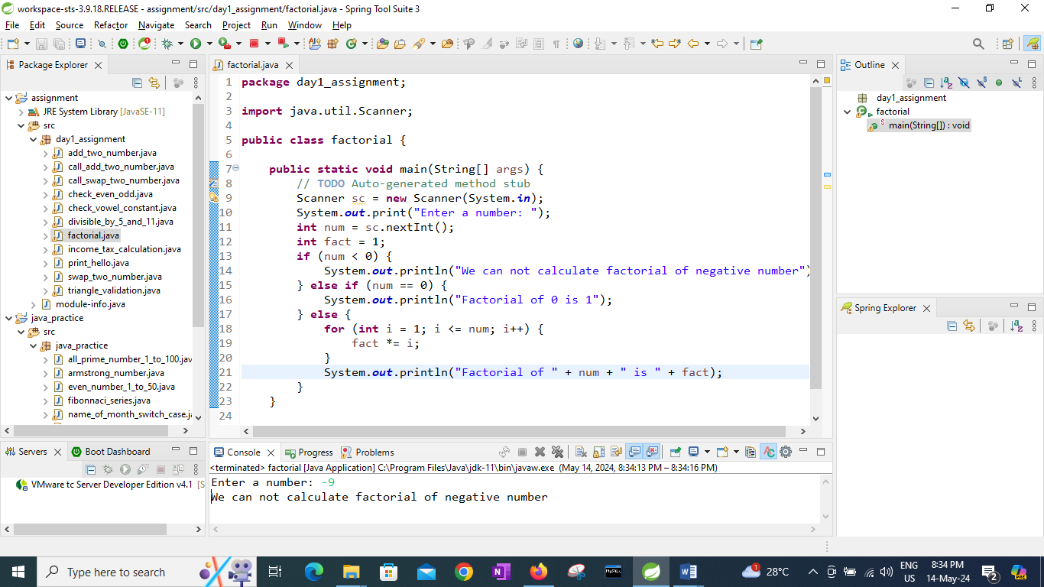

10:Write a program to find m to the power n. m=3 and n=4 so 3\*3\*3\*3

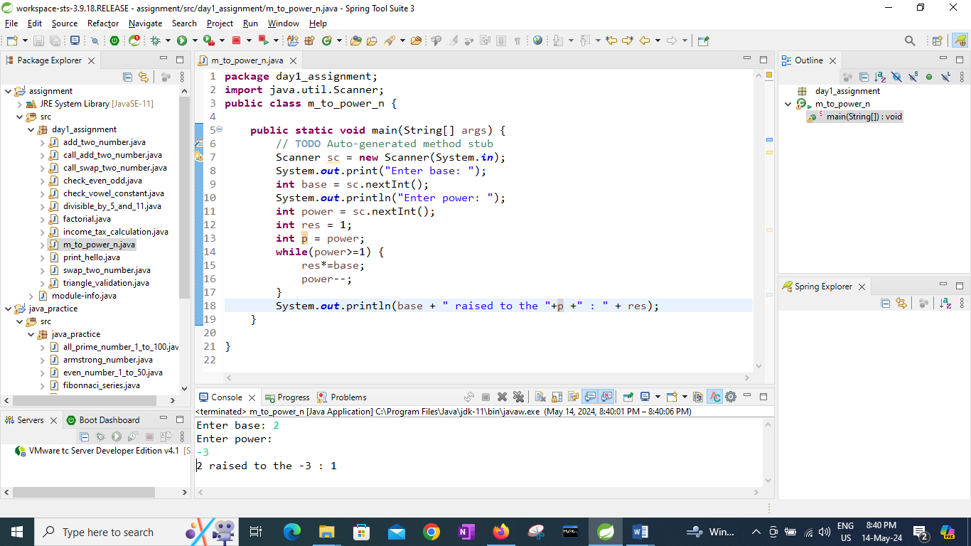

11:Check if number is a prime number or not.:

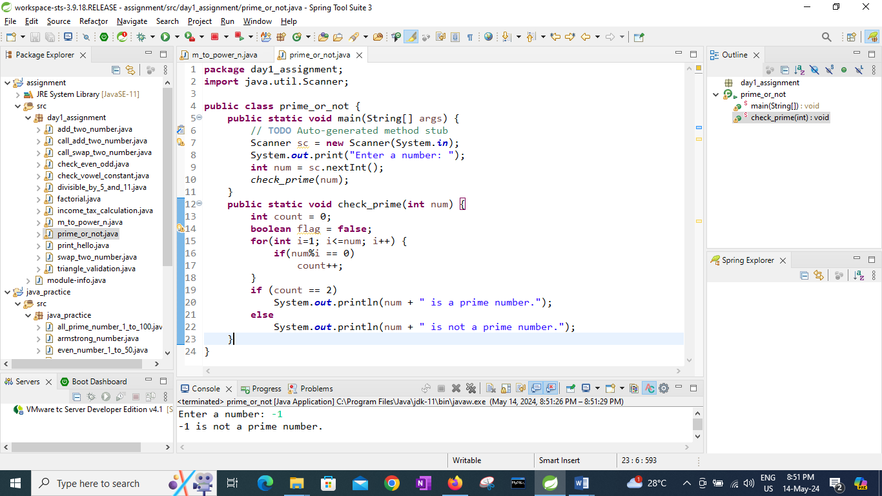

12:Sum of series :

1+2+3+….+n

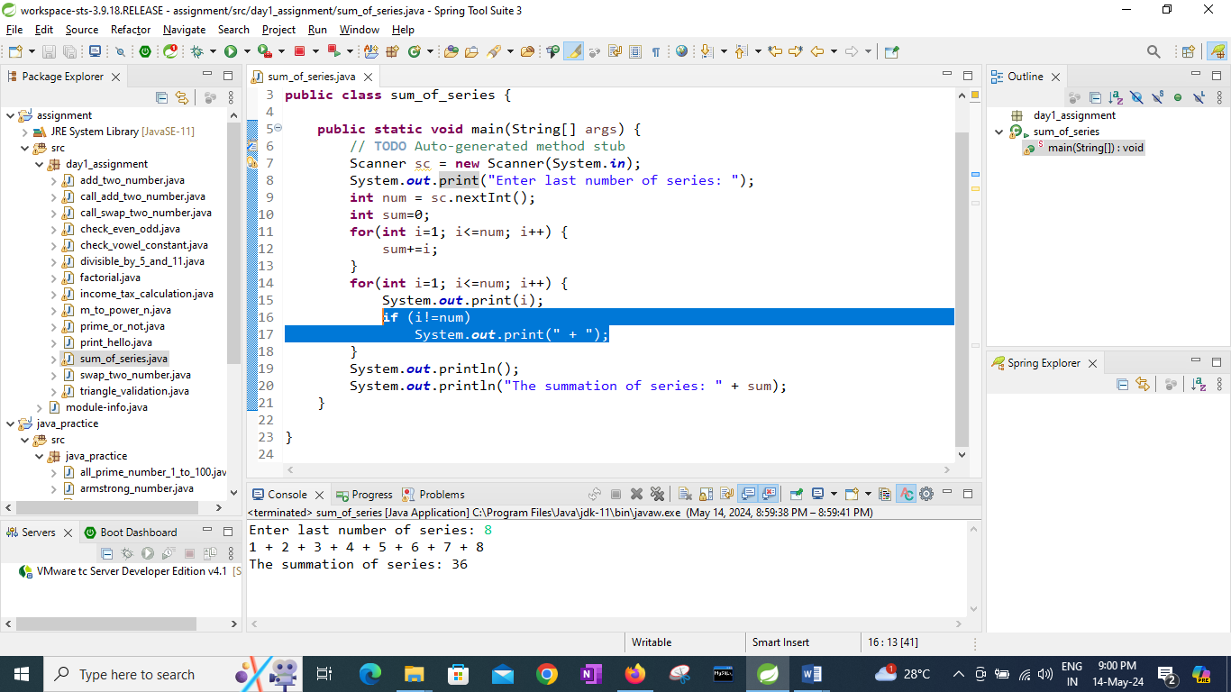

13:Check whether the number is palindrome or not?

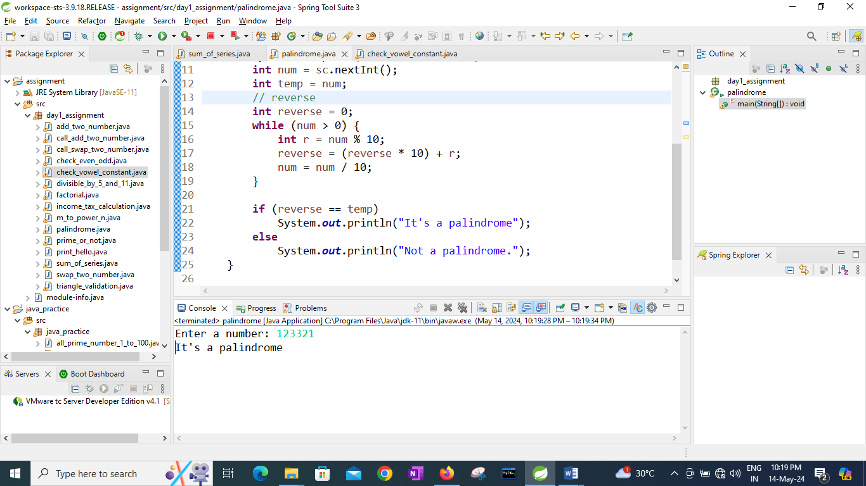

14:Write a program to find sum of all even and odd numbers between 1 to n.

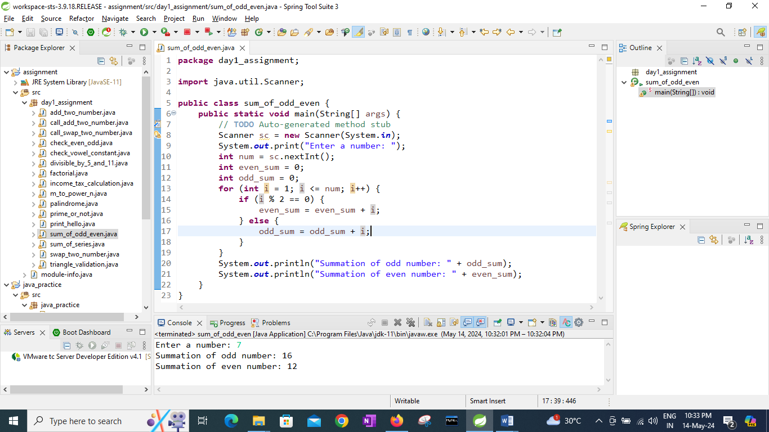

15: Write a program to enter a number and print its reverse.

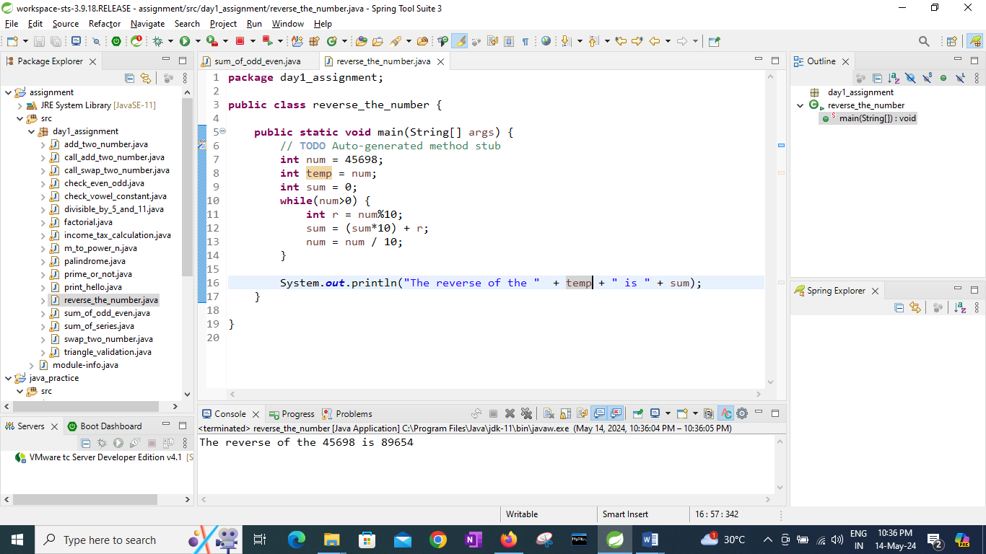

16:Write a program to print all Prime numbers between 1 to n.

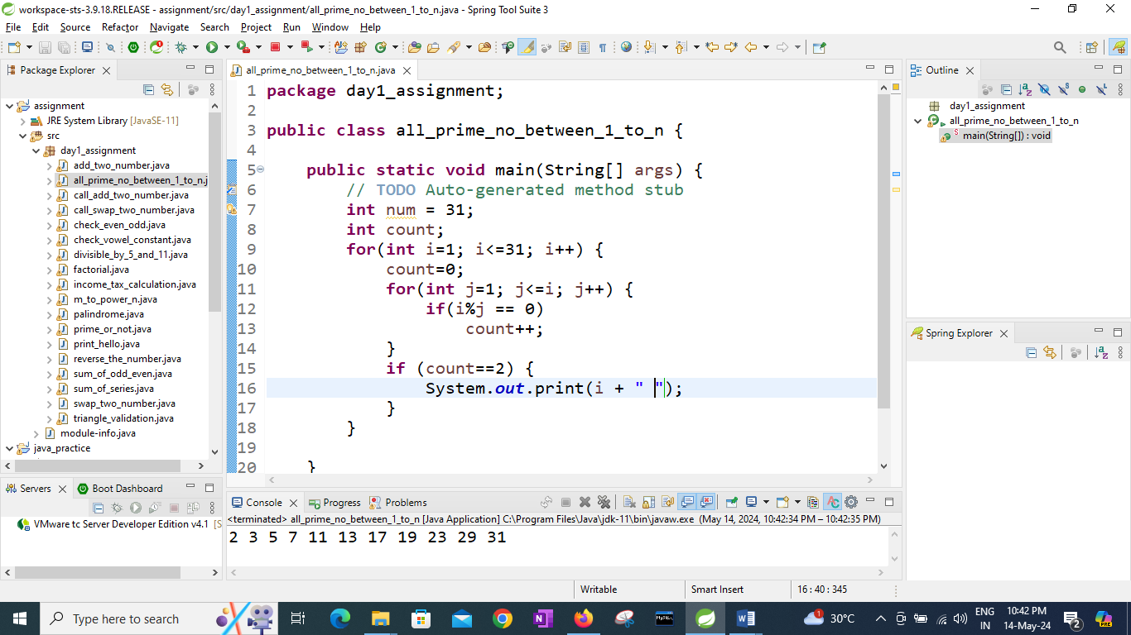

17:Write a program to check entered number is Armstrong number or not.

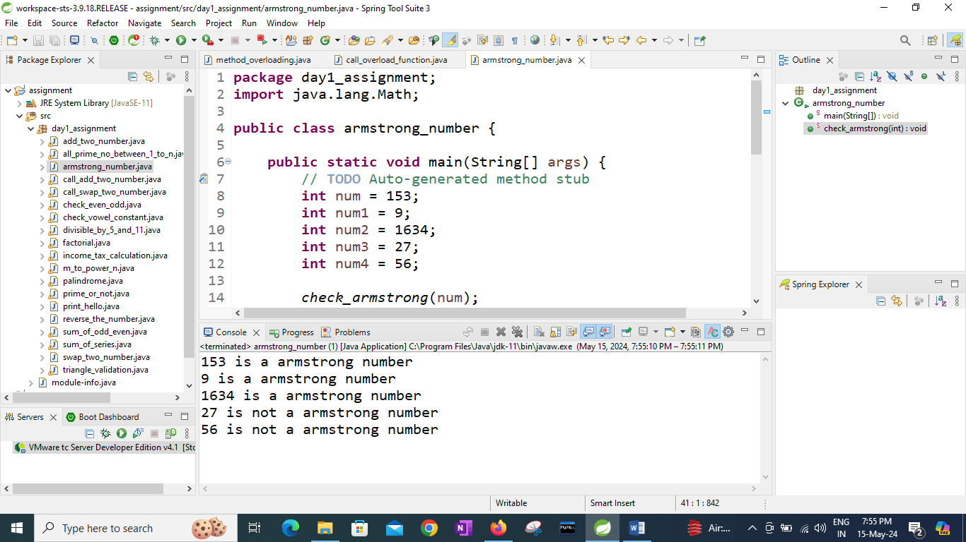

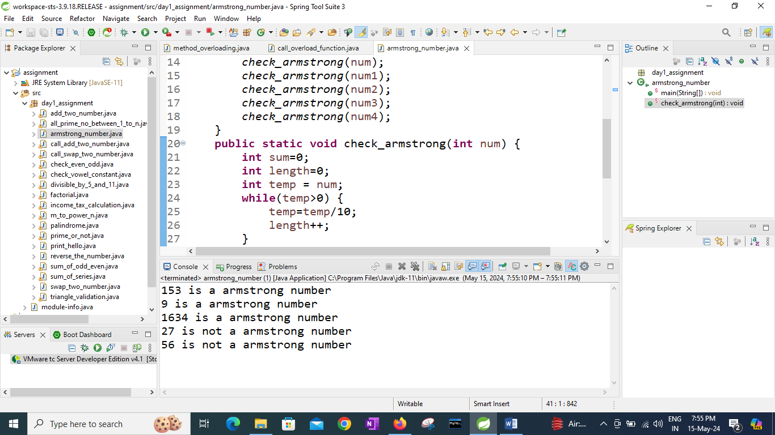

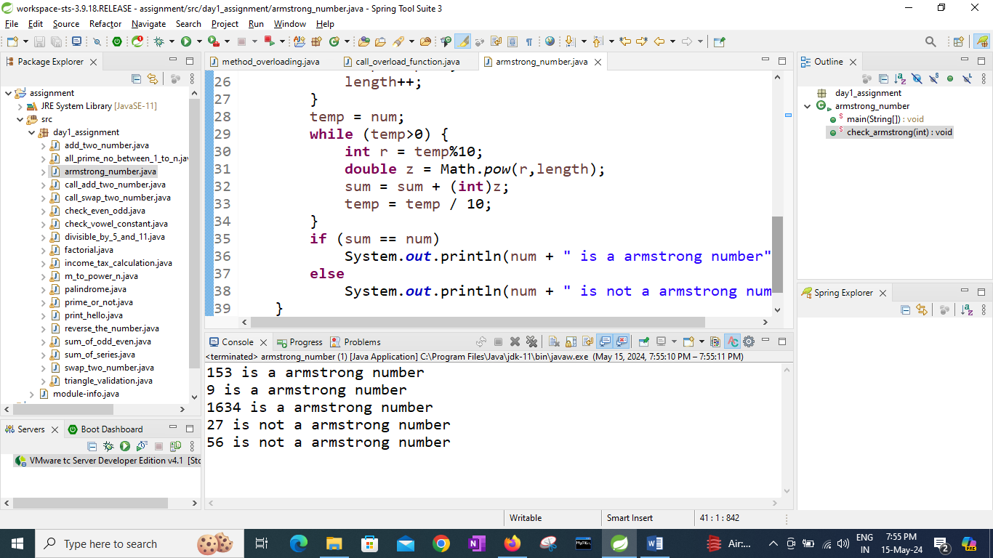

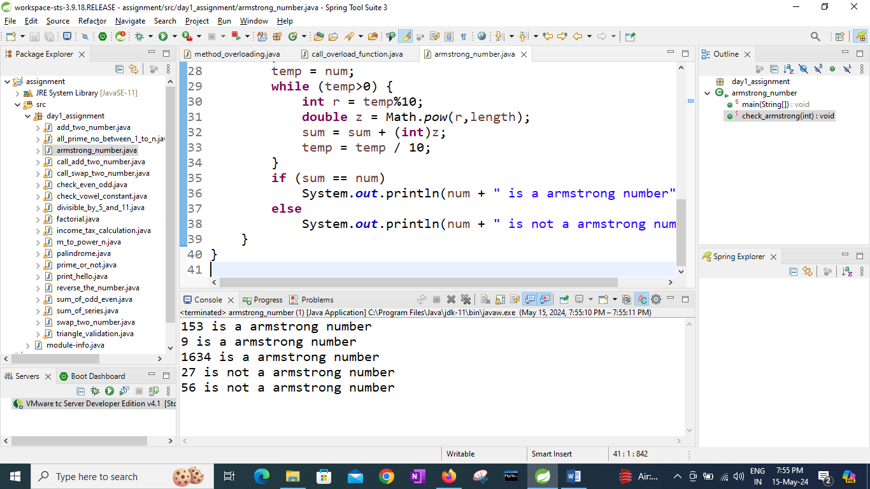

18:Write a program to find greatest of three numbers using nested if-else.

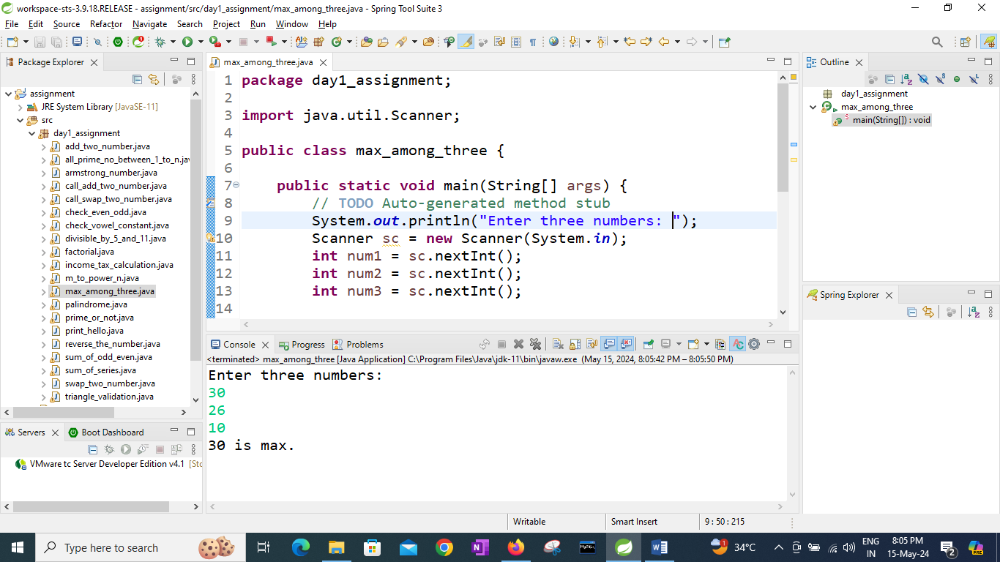

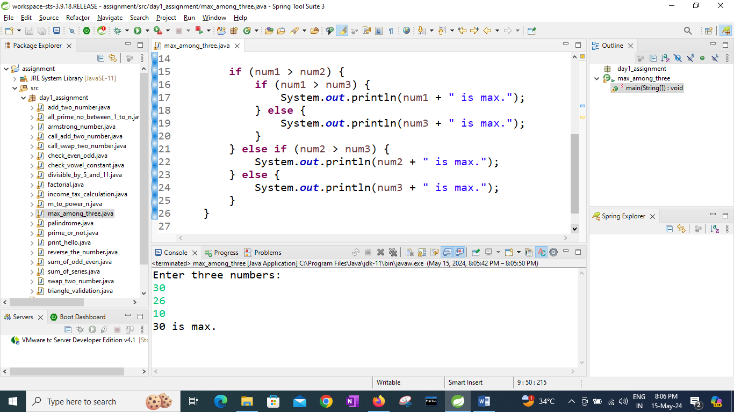

19:Create menu driven program for Pizza Shop. And display total amount.

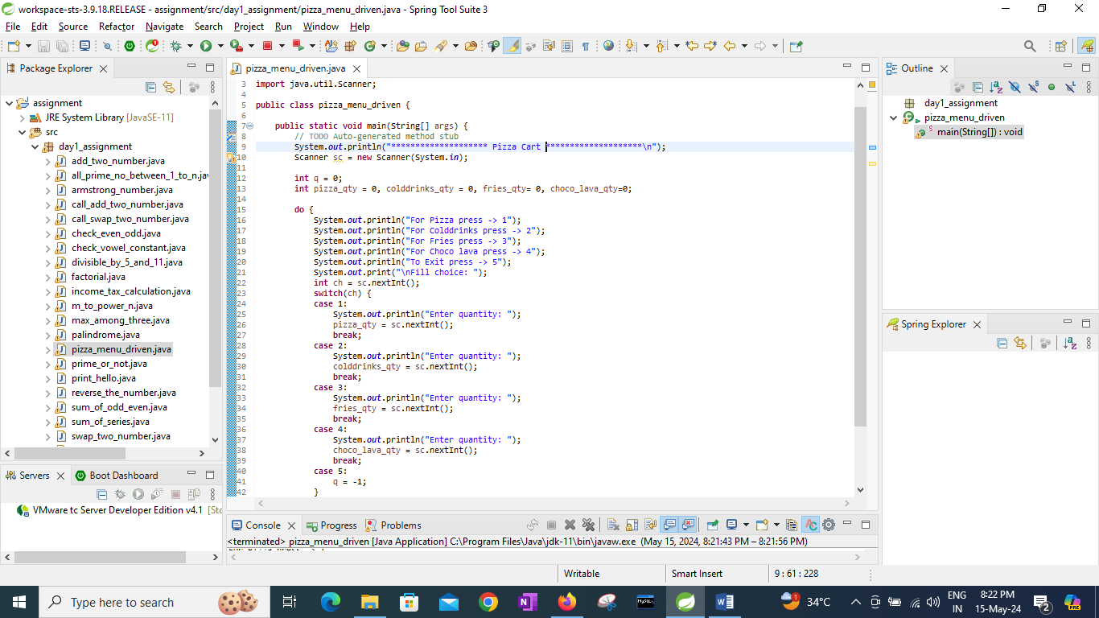

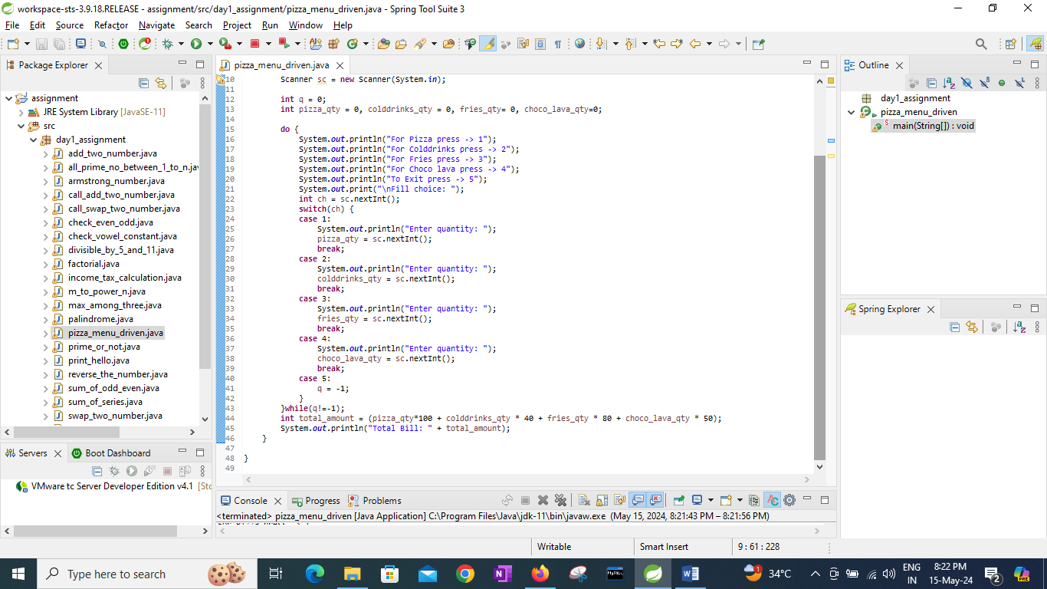

20:Accept a single digit from the user and display it in words. For example, if digit entered is 9, display Nine.

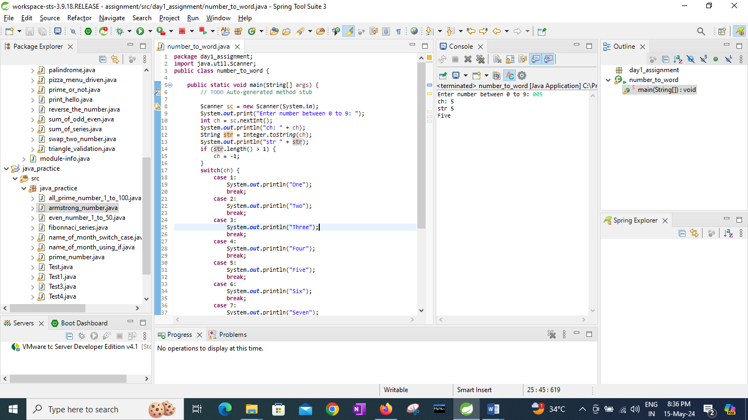

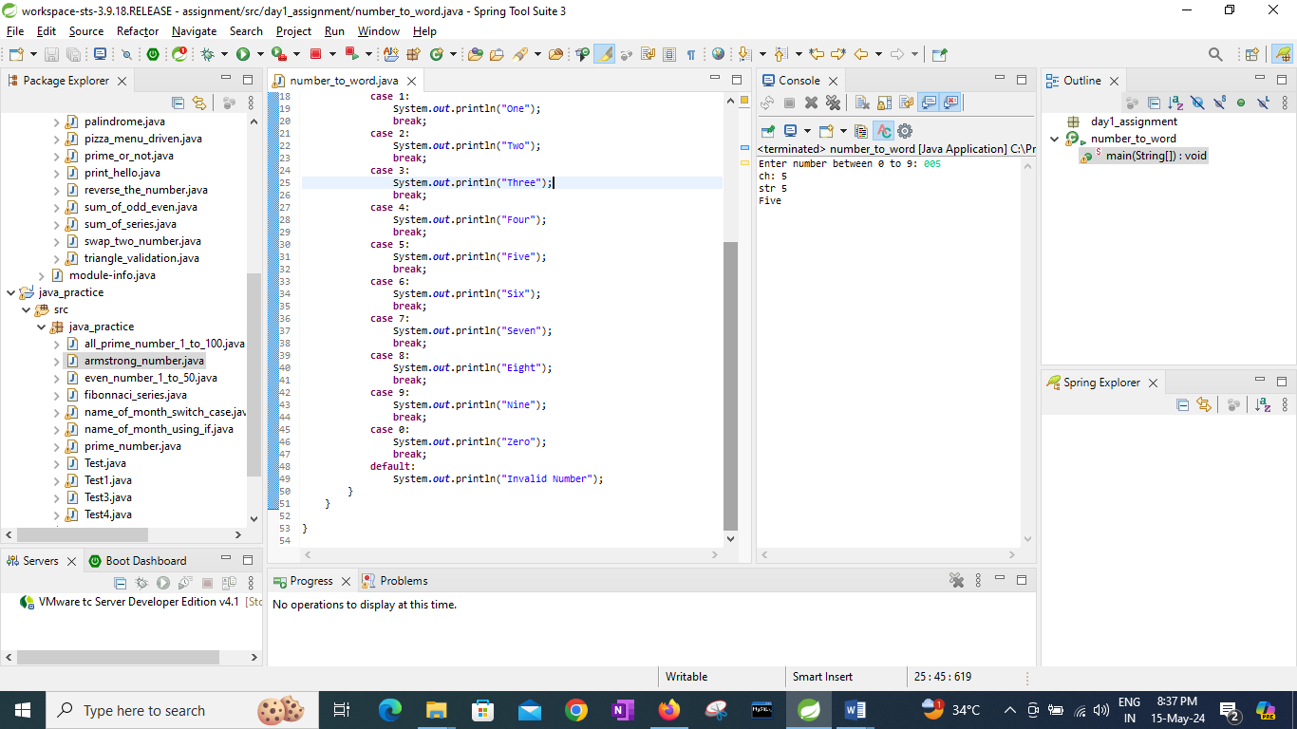

21. Write a program, which accepts two integers and an operator as a character (+ - \* / ), performs the

corresponding operation and displays the result.

